I

**This Month’s Meeting**

Wednesday 10 January: Our speaker is David Dennis who will talk to us about the History, Landscape & Wildlife of Antarctica

President’s Message

*Dear Members*

*I hope you all have had a lovely Christmas and together with the Committee send very best wishes for a Healthy and Happy New Year.*

*Our Christmas meeting was very lively with entertainment by the Chiltern Handbell Ringers, an opportunity to try the tone chimes, wreath making and party food and drink to share.*

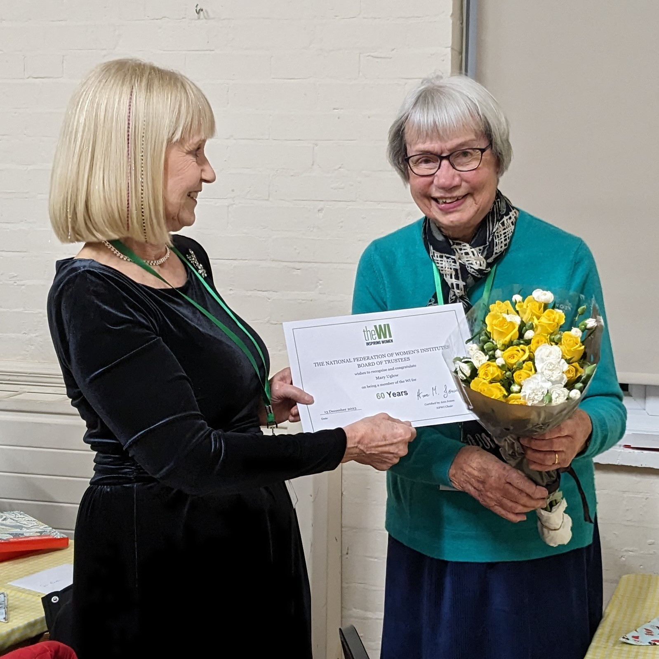*It was such a pleasure to present the certificate for 60 years membership of our WI to Mary and thank her for all her service over these many years.*

*As a result of your generosity I am pleased to tell you that we collected £135 in Tesco vouchers. I delivered the vouchers to Aylesbury Women’s Aid in time for the families staying there to have a few extras for Christmas. Katrina also dropped off the 20 gifts that you generously donated for the Bucks Radio Appeal.*

*This time of the year can feel a little dismal with spring still a long way off but we have lots to look forward to with our meeting on Wednesday, 10th January, post-Christmas lunch at the Peacock on Friday, 19th January and a coffee morning at Fi’s home on Tuesday 16 January at 10:30 am.*

*I look forward to seeing you at our meeting next Wednesday or at one of the other events later in the month.*

Best wishes Alexis

*Sally Manning, Bledlow WI President*

**Bledlow WI Newsletter-December 23/January 24 2023**

**Theatre Group**

The trip to Sonning, on 12 December to see “High Society” was very enjoyable.   The meal before the show was hot and plentiful with lots of chatter.  The singing and dancing in the show were excellent with so many dancers and singers on such a small stage!  A big thank you goes to Sue Butler for arranging.’

One space is still available to see Calendar Girls at Sonning on Wednesday 17 April. Tickets price is £63.75 to include a 2 course meal.

20 people have booked to see 3 Men in a Boat at Sonning on 14 June.

**Interested in Joining a Group?**

Please contact Katrina.

**Request for Used Stamps**

Pat Fricker is collecting used postage stamps for Scannappeal. Please give any you have to Pat or bring to the WI Meeting please.

**WI Reading Group (afternoon)**

The next meeting is Wednesday 24 January at 2.30pm, venue to be arranged.  The book choice is The Marriage Portrait by Maggie O'Farrell, The group has enjoyed books by this author before, and this has a new setting for her in Renaissance Italy.

New members are welcome.

**WI Book Group (evening)**

The group did not meet in December and the next meeting is planned for Tuesday 9 January.

**Walking Group**

Due to Christmas no walks took place in December and the unpredictable weather with floods and strong winds meant no walks in January either. Hopefully February will bring calmer, drier weather.

New members are welcome to join our small group.

**Mini Bridge/Bridge Groups**

Mini Bridge Group meets on the 1st Monday of the month at The Peacock, Henton for lunch, mini bridge and afternoon tea. Then we meet in member’s houses 2 weeks later. The next meeting at The Peacock is on Monday 8 January at 1pm.

Bridge Group meets in members’ houses on 1st & 3rd Thursday afternoons.

**Supper Club**

A small group enjoyed a good lunch from a set menu at La Caravella in Thame. Desserts were limited due to prompt closing and the departure of chef at 3pm. They found it difficult for us to pay individually. Not sure we will return again soon.

The next planned supper club is at lunchtime on Friday 2 February at Miya Japanese Grill in Princes Risborough. More details to follow.

**Gardening Group**

This is the Gardening Group’s dormant period. A meeting will be arranged for February to plan the year’s activities. Margaret will advise on the date.

Watch this space!



The Rummikub Group continues to flourish and meets on the 2nd and 4th Thursday afternoons of the month in members’ homes. This has proved to be very popular and lots of fun (with tea and cake). Next meetings are on 11th January at Sue Butlers and on 25th January (venue to be agreed).



Birthday Greeting to Pam Whatmore for her January birthday.

Belated Birthday wishes to Sue Britnell, Sue Butler and Karen Williams for their December birthdays.

**Dates for your Dairy**

Next Coffee Morning on Tuesday 16 January at 10:30 am at Fi’s home.

Christmas Lunch at The Peacock at Henton on Friday 19 January 2024 where Emma will be talking to us about her catering experiences and the Peacock. Balance payment is due at January meeting. WI is providing a subsidy of £15 towards the cost.